# Audio Book Master

# Abstract:

# The Audio Book Master Project is a comprehensive web application designed to manage and play audio books. The project integrates a user-friendly frontend built using HTML, CSS, JavaScript, and Bootstrap. The backend is powered by Python Flask, facilitating audiobook management and interaction.

# Introduction

# The increasing popularity of audiobooks has led to the development of the Audiobook Master Project. The project aims to provide a seamless and enjoyable experience for users to discover, play, and manage their favorite audiobooks. Leveraging modern web technologies, the project offers a feature-rich frontend and a robust backend to handle audiobook data.

# Requirements

## Hardware Requirements

## A device with a web browser (e.g., desktop, laptop, tablet, or smartphone)

## Internet connectivity for accessing and interacting with the Audiobook Master Project

## Software Requirements

# Web browser (Google Chrome, Mozilla Firefox, Safari, etc.)

# Python installed on the server-side for running the Flask backend

# System Architecture

## The Audiobook Master Project follows a client-server architecture:

## Client-Side (Frontend):

## The client-side is responsible for presenting the user interface and handling user interactions. It is developed using HTML, CSS, JavaScript, and Bootstrap. The frontend provides an intuitive and responsive design, ensuring a pleasant user experience.

## Server-Side (Backend):

* The server-side is powered by Python Flask, a lightweight web framework. It handles backend logic, audiobook data storage and retrieval, and communication with the client-side. The backend ensures efficient data processing and supports features such as adding, deleting, and playing audiobooks.

# Design

The design of the Audiobook Master Project is focused on delivering a visually appealing and user-friendly experience. The frontend design incorporates Bootstrap for responsive layouts and components, providing compatibility across various devices. The backend design follows RESTful principles for efficient communication between the client and server.

# Implementation

## Frontend Implementation:

# The frontend is implemented using HTML for structure, CSS for styling, and JavaScript for dynamic interactions. Bootstrap is utilized to enhance the UI with pre-designed components. The implementation includes features such as displaying audiobooks, playing titles, and managing audiobook entries.

## Backend Implementation:

# The backend is implemented using Python Flask, providing RESTful API endpoints for client-server communication. It handles audiobook data storage in a database and performs CRUD operations to manage audiobooks. Integration with a text-to-speech library allows the system to read audiobook titles.

# Testing

# The Audiobook Master Project undergoes rigorous testing to ensure its functionality, usability, and performance. Testing includes unit testing, integration testing, and user acceptance testing. Various scenarios are considered to validate features such as audiobook playback, addition, and removal.

# Results and Discussion

# The project results demonstrate a successful implementation of an audiobook management system. Users can seamlessly interact with the frontend, and the backend efficiently handles audiobook data. The integration of text-to-speech functionality enhances the user experience.

# Screenshots

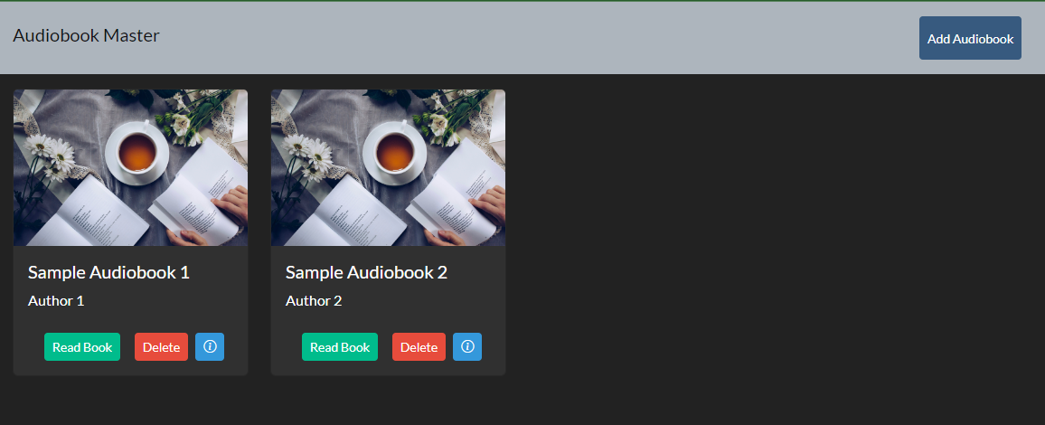

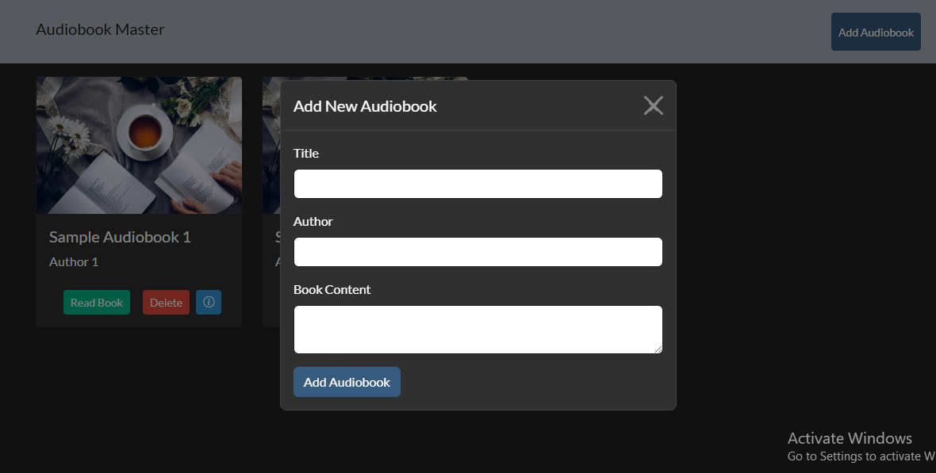

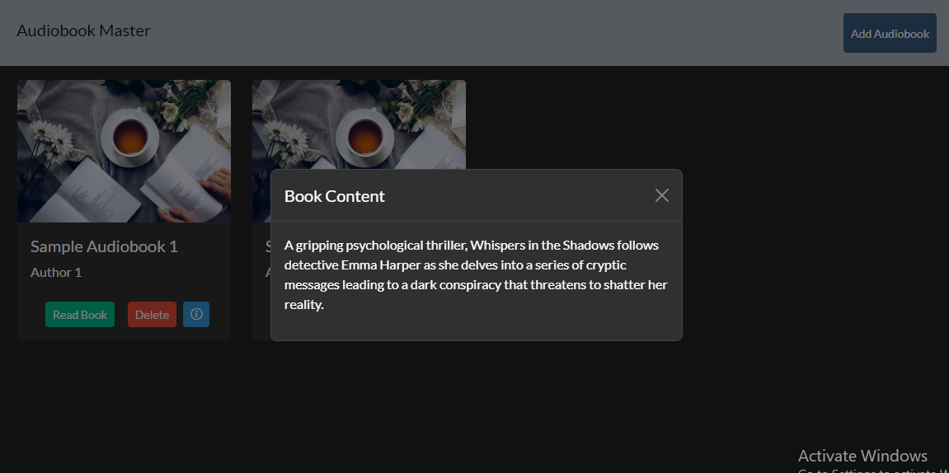

# Conclusion

# The Audiobook Master Project presents a robust solution for audiobook enthusiasts, providing a user-friendly interface and efficient backend functionality. Future enhancements may include additional features such as user authentication, bookmarking, and personalized recommendations. The project showcases the potential of web technologies in creating engaging and accessible audio content platforms.